**Practical 1**

**Aim:** Introduction to cisco packet tracer software.

1)Use different type of devices like pc, switches, cables, pc with wireless card.

2)Create basic topologies and assign IP address, subnet mask, DNS, gateway IP address.

3)Test connectivity with ping command.

# Mesh topology: -

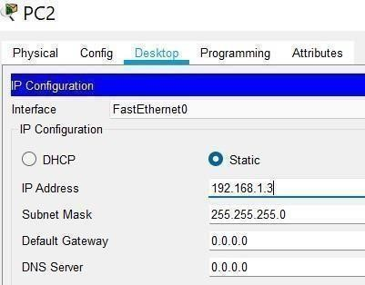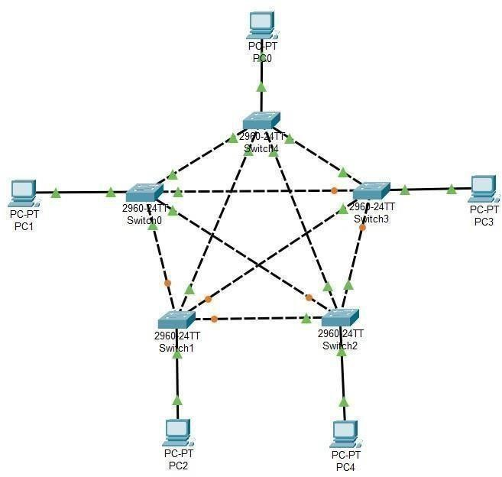

# Star topology: -

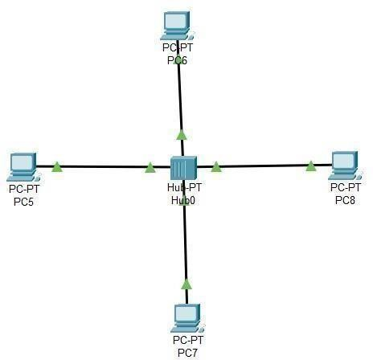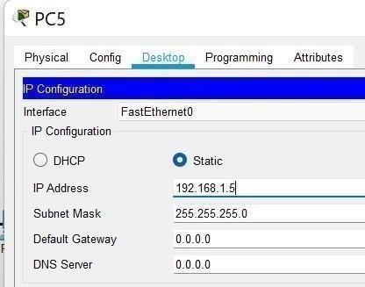

# Bus topology: -

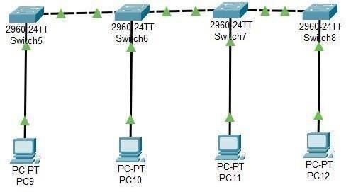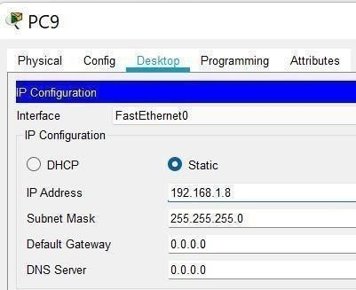

# Ring topology: -

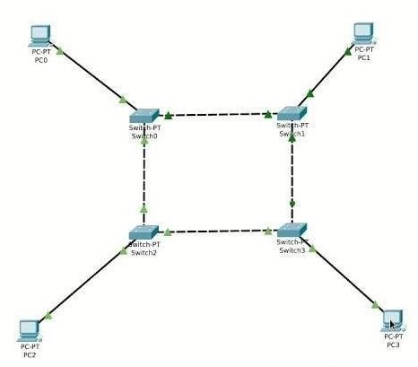

# Hybrid topology: -

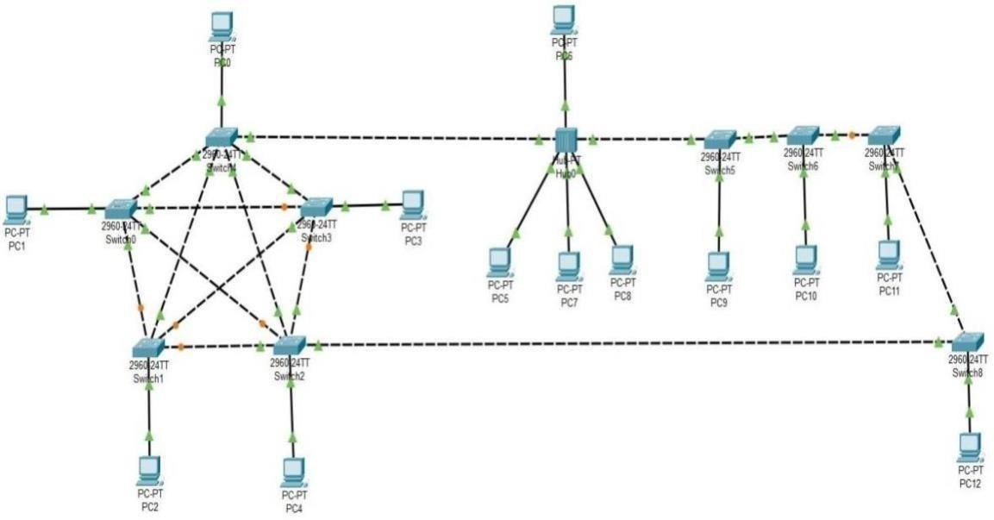

**3) Checking the connectivity using ping command.**

For PC0 :- ping 192.168.1.1

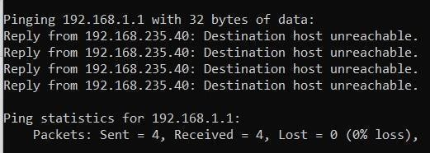

For PC5 :- ping 192.168.1.7

